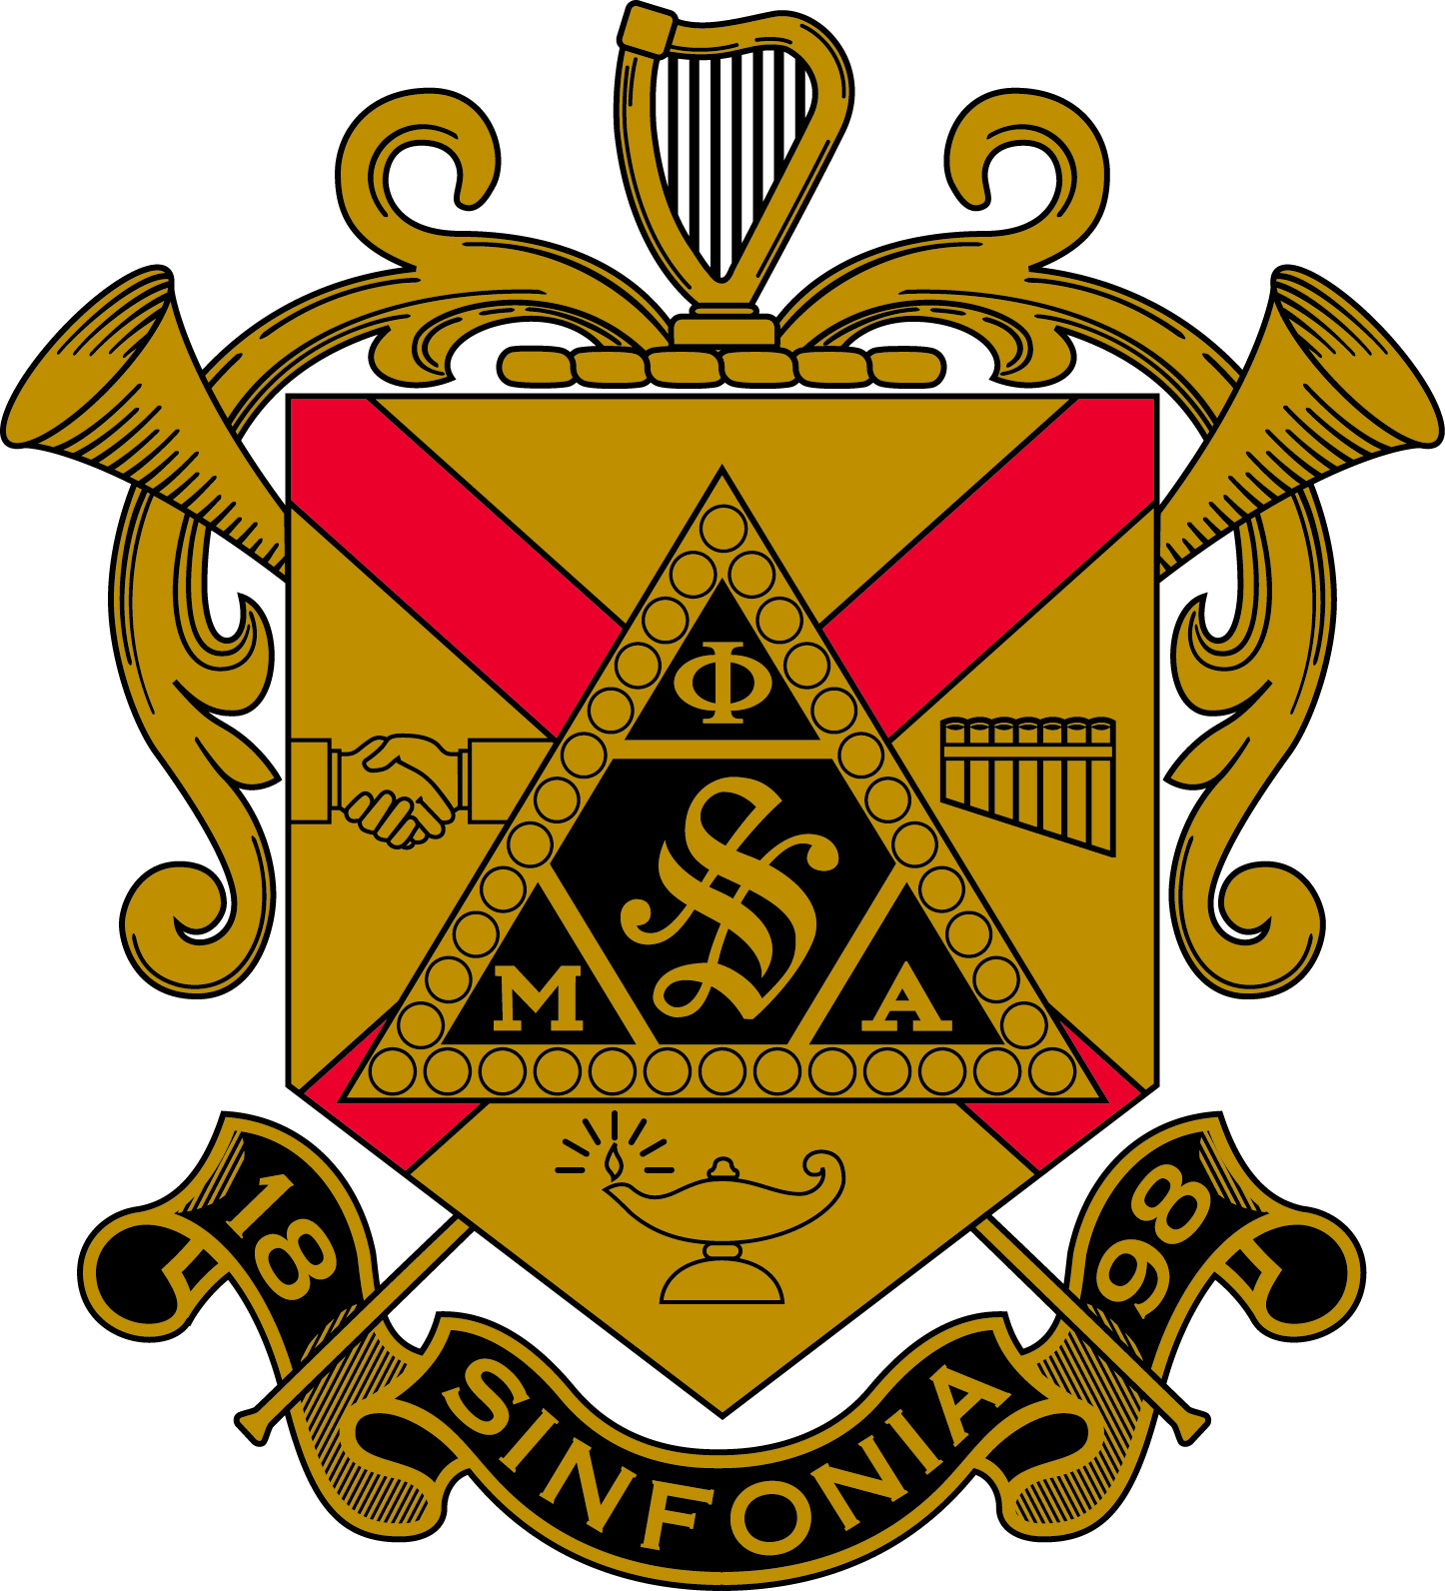

Province Council of the 21st Province
Phi Mu Alpha Sinfonia
Alpha Zeta Chapter – The Pennsylvania State University
Saturday, January 24th, 2015

Meeting was opened at 9:40 am

- Delegate Roll Call
  - Alpha Zeta
i. Brian Bender
ii. Yaman Trivedi
  - Beta Omicron
i. Coleman Lidle
ii. Zachary Sigafoes
  - Iota Kappa
i. Dean Howey
ii. Samuel Porter
  - Lambda Beta
i. Dante Doganiero
ii. Chris Sinunu
  - Rho Sigma
i. Michael W Pettis
ii. Nick Calvano
  - Rho Upsilon
i. Curtis McPeak
ii. Jeremy Sinclair
  - Sigma Gamma
i. Spencer Koppenol
ii. Chris Madden
  - Sigma Lambda
i. Jason Boccuti
ii. Ian Murphy

- Motion for the approval of minutes from November 8th meeting in Sigma Lambda
  - Sigma Gamma stated that the in section III set ii the meeting room is 13G instead of 136
  - Missing delegates from the minutes:
    - Rho Sigma: Sidney Lariar
    - Iota Kappa: Sam Porter
    - Lambda Beta: Herman De-Haan
    - Sigma Gamma: William Smith
  - Minutes Passed

- Financial Report
  - Total: $3931.10 in the checking and savings account, total.
  - Try to get the dues for this semester as early as possible so that they could be taken care of before March.
  - Gas Reimbursement: Fill the gas tank when you leave for someplace and then refill again while making the return trip. Try going for the shortest route and not the fastest so that the province money can be used for some other purposes.
  - Once you reach back, send all the receipts to Robert Wittmoyer through mail.

- Chapter Reports
  - Alpha Zeta
    - 7 Total Collegiates (all in good standing)
    - No honorary initiation
    - Meeting time: Wednesday 8:30 pm , Rm 1, Music Building 2
    - Dues: $140
    - Pinned in 3 guys on January 23th
      - Second Pinning to happen on january 30th
    - Expelled 1 brother last semester
    - No R date selected yet.
  - Beta Omicron
    - 12 Total Collegiates (all in good standing)
      - 1 on professional
    - No honorary initiation
    - Meeting time: Thursday 8 pm, Butler 202
    - Dues: $140
    - Pinning on Feb 1st
    - Expected R date: April 18-19
  - Iota Kappa
    - 24 Total Collegiates (all in good standing)
      - 6 on professional
    - 1 honorary initiation last semester
    - Meeting time: Sunday 7 pm, Blaire 123
    - Dues: $130
    - Pinning on Feb 1st
    - Tentatively on March 14, 5pm in Zimmerman recital hall
  - Lambda Beta
    - 39 Total Collegiates (all in good standing)
    - 1 brother expelled last week.
    - Meeting time: Sunday 1pm in Model Classroom
    - Dues: $160
    - 15 bids were given out (pinning on Feb 2nd)
    - AMR and Fundraising events soon
  - Rho Sigma
    - 29 Total Collegiates (all in good standing
      - 1 on professional
    - 1 brother expelled last semester
    - Meeting time: Sunday at 7pm, 225 Swope music building
    - Dues: $150
    - AMR on thursday Apr 30 at 8 pm
    - No R date selected yet.
  - Rho Upsilon
    - 35 total Collegiates (32 in good standing)
    - 3 on suspension and expelled 1 brother
    - Meeting time: Monday at 7pm in Preser Hall
    - Dues: $100
    - Pinning on Feb 13th
    - Ritual date: April 25
  - Sigma Gamma
    - 15 total Collegiates (all in good standing)
      - 3 on professional
    - 2 expelled last semeseter
    - No Honorary initiation
    - Dues: $125 (subject to change)
    - Sinfonia Recital on Apr 3
  - Sigma Lambda
    - 18 total collegiates ( all in good standing)
    - 1 expelled last semester
    - Meeting time: Sunday at 7pm in music building room 202
    - Dues: not decided yet
    - No R date decided yet

- Colony Report
  - Lincoln University submitted for phase 1 on Dec 1st but wasn’t approved. They will be submitting again on May 1st. If everything goes fine, they will submit it again and will be chartered in the Fall semester.
  - Millersville university has shown some interest

- Alumni Associations
  - The interest group in Philadelphia is about to be up and running
  - Eddie Richet (Rho Upsilon) is trying to get it through.
  - There has been interest shown in Harrisburg and Central PA areas. Alumni associations have to be a mix of people from different chapters.

- Commitee Reports
  - Chapter Bylaws need to be sent to cpr21@sinfonia.org. Bylaws shouldn’t be more than 12 pages long.
  - Advocacy and outreach:
    - Sigma Gamma was looking to help Alpha Zeta with the numbers. Alpha Zeta needs to reach out to people and can contact Brother Will Smith (wsmit862@live.kutztown.edu) or find him on Face book.
    - There was interest shown at Bloomsburg. Lambda Beta went up but their GPA wasnt high enough.
    - Also for a new chapter to start there needs to be a music program in the College/University
  - Colony development is very important, talk with Brother CPR
  - Technology:
    - There was no province website, so CPR has made a weebly site. All the resources and information is on there. province21sinfonia.weebly.com
    - Listserv: mail.sinfonia.org .Please get on this listserv, get on the national and the province one if you want.
    - Facebook: Only Chapter Presidents have been given the access to add people so the best way around this is to add people as soon as they get initiated.
    - Google Hangout: This time we tried something new by having the brothers of Sigma Lambda via video call through the hangouts.
    - Now we just need to get everything documented and have it somewhere.
    - There was a possible idea of a new job of the Province Historian.

- Province Officer Reports
  - Province Music Director:
    - Music time: “A Serenade to a Girl”, “Brother to Brother”
    - There should be a Province AMR once a semester.
    - We can have one in April when we have the workshop.
  - ACPR:
    - Brother Brian Bender has stepped down from his position as the ACPR. He was unable to make it to the November meeting and the CPR Convocation. The elections for the new officers will be in April (Province workshop).
    - If interested in running for the ACPR or any other position, you may contact Brother Bender, CPR Brother Gibson and the PG Brother Whitmoyer.
    - Brother Bender will be sending the newsletter for a last time so get all the related material to him.
  - CPR:
    - CPR convocation was at Lyrecrest from Dec 26th 2014- Jan 1st 2015.
    - The national convention is in New Orleans this year from July 8th -12th. By March 1st we have to docket everything of all the legislation for the national convention.
    - Convocation tax is $80 right now for every chapter per semester. Now for this national convention, we are about $110,000 short, so the convocation tax may double then so, it is expected to be $320 per year.
    - For the remaining money, it has to come from the brothers. There is also a chance of insurance going up because of risk management.
    - Fireside Conference to be hosted by Mansfield University in March. Every chapter needs to have representation. The average cost for the weekend would be about $150, which includes lodging, food and registration fee.
    - We might need to get some Alumni support to set up for the fireside conference.
    - Iota Kappa has conflict with a choir performance. Also Temple has march madness around the same time.
    - Schedule for the Province Workshop held at Iota Kappa in April is already up. For the workshop, we can open on Saturday and close on Sunday. We can have nominations on Saturday and elections on Sunday. Each chapter needs to have 5 guys at the workshop. For any questions, email to drh003@lvc.edu or Julian Gerace.
    - Cabin retreat at Robb’s cabin. Think of a date in March and have it approved by April.
    - For the national Convention:
      - Housing at the Sheraton-New Orleans
      - Options for transportation:
        - Flight~$400
        - Bus~$300
        - Train~180
        - Car is the cheapest but depends on how many guys go
      - Total cost will be about $500 for registration and hotel.
      - According to the Province Incentive Program, based on the citations, you get points. First place chapter gets 3 free registrations, Second gets 2 free registrations, and third place gets 1 registration.

- Province Governor Report:
  - Congratulations to all the new presidents
  - $1 raffle at the Banquet
    - Donation of $24 to the SEF from the Banquet
  - There are 2 brothers interested for the Province Alumni Coordinator position.
  - Brother Don Kramer from Alpha Zeta is the new president of SEF. Applications for that will start soon for 7 scholarships and about $25,000 total to be given out.
  - Whenever an R date is set up, always have another back up date just in case.
  - Chapter reports are due on March 15, also the dues are due on the same day. Also send the RMA signatures along with the chapter reports..
  - Province dues are $8 for collegiates and $4 for PMs.
  - Citations are due on May 1st.
  - People who want to go for the national convention need to have attended a province workshop.

- Old Business: None

- New Business: for the 2 colonies in Maryland, a delegation should be sent.

- PM’s were excused and the meeting was closed according to ritual at 7:45 pm

Respectively Submitted,

Brother Yaman Trivedi
Secretary of Alpha Zeta Chapter of the Phi Mu Alpha Sinfonia

And

Brother Joshua Michael Gibson
Collegiate Province Representative – Province 21 of Phi Mu Alpha Sinfonia

