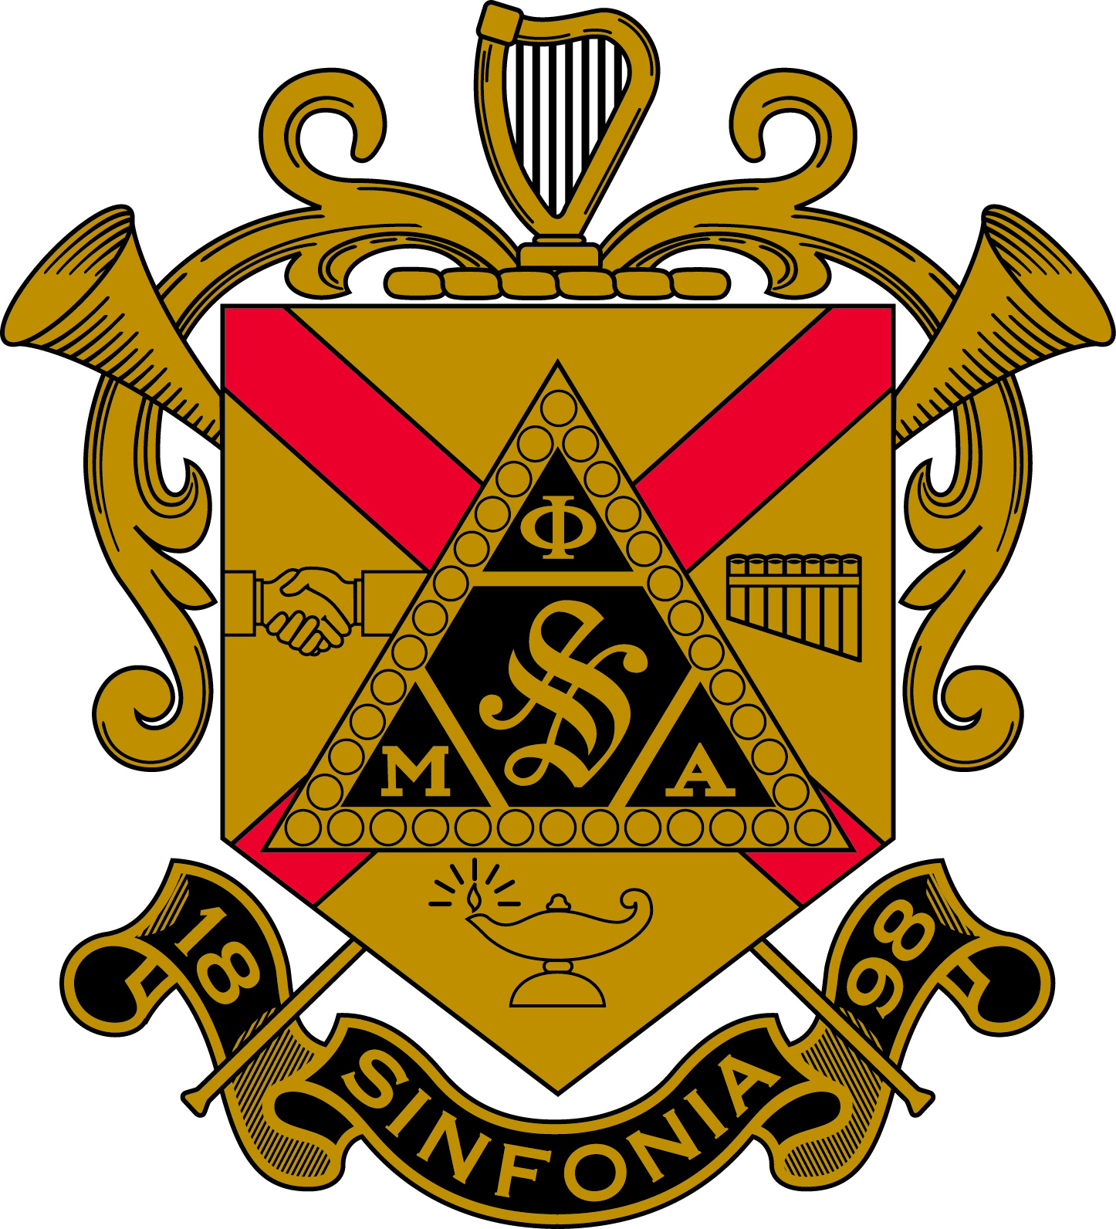
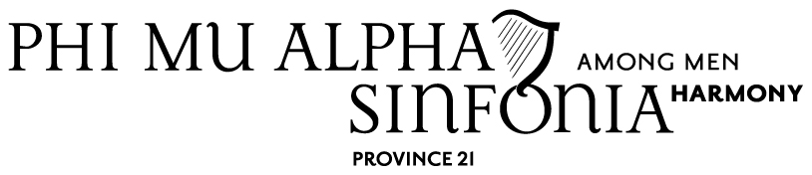

Meeting of Province 21 Held at Sigma Lambda at Moravian College in Collier Hall of Science on November 8th, 2014
- Meeting was opened at 4:00 PM
  - PM's and Colony Members were shown out
  - No installation ceremony
  - Delegate roll call
    - Alpha Zeta
      - Chris Fuller
      - Michael Evans
    - Beta Omicron
      - Zack Minnier
      - Morgan Feick
    - Iota Kappa
      - Adam Rabenold
      - Not Listed
    - Lambda Beta
      - Benjamin Gottlieb
      - Not Listed
    - Rho Sigma
      - Nick Calvano
      - Not Listed
    - Rho Upsilon
      - No Delegates Present
    - Sigma Gamma
      - Sam Weiss
      - Not Listed
    - Sigma Lambda
      - Jason Boccuti
      - Benjamin Wallace
    - Philadelphia Alumni Association (Interest Group)
      - Edward Richet
  - Motion for the approval of minutes
  - Sigma Gamma stated that in section V set II, location to be changed to Schaefer *room 13G all other amendments made to the minutes will be handed in and all necessary changes will be made.
  - Minutes were passed from the last province meeting
- Financial report
    - 4,035.54 in the checking and savings account, total.
- Chapter reports were read.
  - Alpha Zeta
    - 8 Total Collegiate Chapter Members
      - 7 in Good Standing
      - 1 Suspension – Dues
    - Meet 9 PM on Thursdays – Room Varies – Weekly
    - $140 dues per semester
    - Suspended Probationary Member Class for Fall 14. Focus on Recruitment for Spring 15
    - Bandorama Friday November 14th, Eisenhower Auditorium at 7 PM
      - Blue Band and Penn State Symphonic Band
  - Beta Omicron
    - 14 Total Collegiate Chapter Members
      - 12 in Good Standing
      - 2 on Professional Semester
    - Meet 9 PM on Thursdays – Butler Music Center Room 202 – Weekly
    - $140 dues per semester
    - 2 PM’s to be initiated on Sunday November 23rd, 2014 at 9:30 PM in Steadman Theatre.
    - AMR December 7th at 7:00 PM
    - MMM November 15th and December 6th
    - Pre Recruitment Week to be in December
  - Iota Kappa
    - 24 Total Collegiate Chapter Members
      - 23 in Good Standing
      - 1 on Professional Semester
    - Meet 7 PM on Sundays – Blair Music Center Room 23
    - $130 dues per semester
    - 2 Probationary Members – Initiation set for 11/9/2014 at 9:00 AM in Zimmerman Hall
    - Rover’s American Music Recital on Sunday 11/23 at 3:00 PM
    - Christmas Caroling
  - Lambda Beta
    - 42 Total Collegiate Chapter Members
      - 40 in Good Standing
      - 2 on Professional Semester
    - Meet 1 PM on Sundays – Seibert hall – Weekly
    - $160 dues per semester
    - Proceeding with Process despite no PM class this semester
  - Rho Sigma
    - 26 Total Collegiate Chapter Members
      - 23 in Good Standing
      - 2 on Professional Semester
      - 1 Recently Expelled
    - Meet 7 PM on Sundays – Swope Music Building – Weekly
    - $150 dues per semester
    - Ritual was 11//8/2014 at 9:00 AM – Initiated 2 new brothers
    - Recently had Fall Musicale
    - Sinfoniagiving Coming Soon
  - Rho Upsilon
    - Not Present
  - Sigma Gamma
    - 16 Total Collegiate Members
      - 15 in Good Standing
      - 1 on Professional Semester
    - Meet 7 PM on Sundays – Schaeffer Auditorium Room 136
    - $125 dues per semester
    - Initiation 11/8/2014
    - Orpheus Award Presented to Dr. Willis Rapp
    - Caroling 12/6 at 7:30 PM
    - 3 - 25 year Sinfonians to be Recognized and 1 - 50 year
  - Sigma Lambda
    - 17 Total Collegiate Members
      - 17 in Good Standing
    - Meet 7 PM on Sundays – Brethrens 202
    - $79 dues per semester
    - December 4th at 9:30 PM Initiation in Moravian College Concert Hall
    - 2 PM’s passed National Exam
    - November 24th upcoming concert at 8:30 PM
    - Bethlehem Advent Calendar
    - Sang for Open house
    - Information Session for Prospective Members
  - Philadelphia Alumni Association (Interest Group)
    - 9 Interested Members
    - Meet Montly
    - Next Meeting, Sunday November 23^{r} at 5PM
      - Copobanana (South Street)
    - Nominating Officers this week
    - Filing Paperwork
    - ARO’s can contact Eddie at erich293@gmail.com
  - Colony report was read from Lincoln.
- Committee reports... Province is in need of Committee Chairs.
  - Brother Mark Feld -Bylaws
  - Brother William Smith- Advocacy and Outreach
  - *Brothers are needed to chair other province committees
- Province music director asked if chapter presidents and music directors to get in touch with him. He will be giving out music to work on for the Province Workshop Recital. Also, he will try to begin and maintain contact in a Google Chat with Chapter Music Directors.
  - Brother Bender, ACPR, said that all submissions to province newsletter should be sent to him. Also said he would like to visit more chapters in the following semester.
- Official proposal of trip to National Convention presented by Brother Gibson on behalf of Brother Bender, ACPR. Costs, reasons for attending, reason for using RV to attend and cost for RV.
  - It is unknown whether we are supposed to vote on this now or later in the spring semester at the workshop at Penn State.
  - The consensus was that chapters should deliberate and bring numbers and concerns to province workshop in spring.
  - Governor Whitmoyer discussed the possibility of a bus going down the east coast and picking up Brothers on the way to Nationals.
  - Brother Richet offered to share some numbers regarding travel costs if desired by chapters.
  - *It was brought up by Kutztown that they tried to contact Bender... Communication was not made.
- PG report
  - All chapters should have documented celebrating 2014 Founders Day.
  - Sigma Lambda was recognized for hosting the 11/8/14 province meeting
  - CPR and Governor Whitmoyer need minutes from all chapters.
  - Temple communicated that they would be able to attend the Province Meeting today
  - 4 rituals have been scheduled throughout the province
  - Better communication is needed from chapter to CPR and PG
  - Colony at Lincoln is recognized and will submit to move to Phase 2 on December 2. Rho Sigma is mentor chapter to Lincoln.
  - Governor Whitmoyer will continue to take chapters on retreats to the cabin... Any interested in should inquire.
  - Brother Richet was recognized and thanked for the gift of the Gavel.
  - Any time a brother is expelled the minutes of that decision must be sent to Headquarters to go into the chapter file.
  - Governor Whitmoyer will be accepting Gas receipts from September.
  - National Convention in New Orleans on July 8-12 2015... Every chapter must be represented.
- Music rehearsal.
  - Pg. 22 "A Call to Sinfonia"
  - Pg. 84 Sinfonia Grace
  - Pg.79 Doña Nobis and Sinfonia Hymn
- Old Business
  - Province Alumni Coordinator. Had 4 PAC’s now down to 3
  - Brother Richet spoke as to why he would like to be PAC.
  - *2 other possible PAC candidates who were not in attendance. Governor Whitmoyer will contact out to those Brothers.
- New Business
  - Province 21 Budget Proposal which was presented by Brother Gibson
  - Brother Gibson also talked about the cost of Sinfonia having a booth at PMEA in Hershey in March of 2015 teaming up with Province 39. It would cost approximately $1,400. Our total would come to 815 after province 39 said they could officially participate. Brother Gibson asked of Brothers views and who would like to get involved. If 39 backs out we will get one booth and the cost will essentially remain the same. (March 27-29)
    - A motion was made by Rho Sigma and seconded by William Smith III of Sigma Gamma to vote to allocate funds from the account to participate in PMEA.
      - Unanimous yes by delegates on PMEA vote
  - Province 21 was contacted by Vice President Lichtenberg to host Northeast Fireside Conference.
    - 2 chapters have offered to host. Penn State the 2 (Kutztown and Susquehanna) others backed out.
    - Also, the possibility of combining a workshop and conference was proposed. Beginning on a Friday night and ends Saturday... Sunday is a day for travel.
    - Floor was opened to any chapters who could host this conference. Possible dates in March and April.
    - Iota Kappa said they would like to host, but the dates aren't available for them... But a change of date could work if combined with a workshop.
    - It was recommended that the conference and council meeting could be combined at Alpha Zeta (Penn state)... Would be good for rebuilding Chapter foundations.
    - It was asked which date suited chapters the best Fireside Conference Date March or April. All chapters should email CPR and PG about which date would suit best.
  - Lincoln, if passed to Phase 2 will be installed in March or April... Tentatively March 15th.
- Workshop
  - Iota Kappa at LVC
  - April 10-12.
  - Friday, Saturday and Sunday is travel time... with meeting being at 1 on Saturday
  - *Tentative schedule to be released and planned at next meeting.
- Meeting at Penn State January 23-25 for Council Meeting (snow date weekend that follows)
  - Motion made by William Smith Sigma Gamma and seconded by Alpha Zeta for Penn State Council meeting on January 23rd and snow date.
  - Motion passed unanimously.
- Tonight Sigma Gamma will have their initiation at Kutztown at 9:00 PM.
  - 9:00 AM Initiation at Iota Kappa at LVC on November 9th, 2014.
- PM's and Colony Members were excused
  - Meeting was closed according to Ritual at 6:00 PM

Respectively Submitted,
Brother Joseph L. Mozingo
Secretary of Sigma Lambda Chapter of Phi Mu Alpha Sinfonia
and
Brother Joshua M. Gibson
Collegiate Province Representative of Province 21 of Phi Mu Alpha Sinfonia

